Problem 2: SkyWardrobe (Real-Time Weather Advisor)
This challenge requires you to build a lifestyle utility service that bridges the gap between live environmental data and daily user needs. You will create an application that fetches real-time weather metrics and processes them through a custom logic engine to provide context-aware clothing recommendations for the user.
Core Requirements:
Data Integration: Fetch live weather data (temperature, humidity, precipitation) from a public API like OpenWeatherMap.
Recommendation Engine: Map weather states to a local dataset (JSON or Database) of clothing items to generate a logical "Outfit of the Day."
Resiliency: Implement a fallback strategy for when the third-party API is unreachable or rate-limited.
Key things to note:
How you define the thresholds for specific weather categories (e.g., "cold" vs. "chilly").
Handling high-traffic scenarios, such as 10,000 users requesting advice at the same time.

First lets look at the type of data coming in from OpenWeatherMap
API Key: d07a1b52250ff24c45fc10870ef95cb4
Example output:
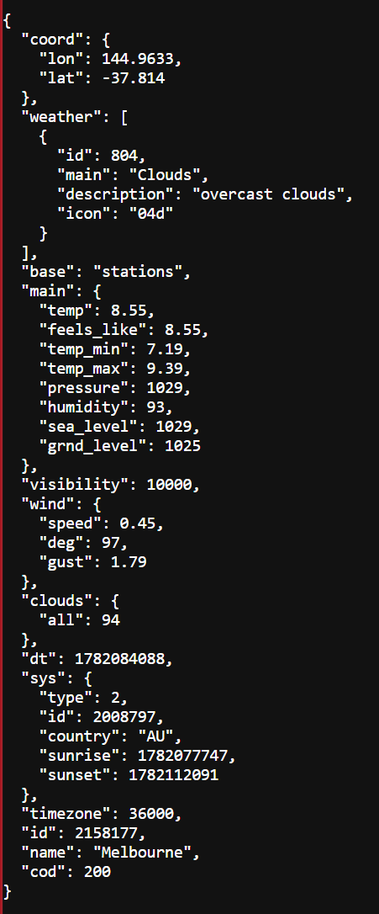

Now that I know what the output actually looks like, I can have a js script which calls the api, parses the api and then is able to display this information. After install the dependencies and creating a .env file for the api key, start the logic.js server port 3000 and access http://localhost:3000/weather
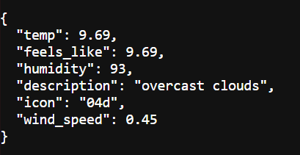

Now we can work towards building a proper frontend for showing this information, then the clothing recommendations stuff

